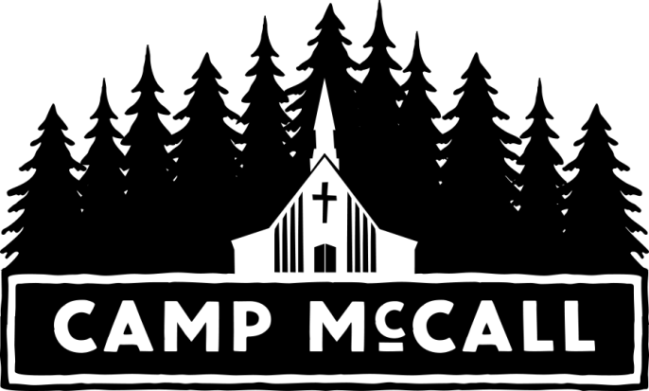

SUGGESTED PACKING LIST FOR RETREATS

CLOTHES

____ Socks
____ Shirts
____ Shorts
____ Shoes (At least 2 pair, 1 pair that can get wet; closed-toed shoes with straps are recommended.)
____ Swimsuit (All females must have a 1-piece bathing suit.)

____ Jeans
____ Underwear (plenty)
____ Rain Wear or Poncho
____ Hat/Bandana
____ Other Clothing Items
____ Jacket, Sweatshirt, warm clothing for evenings

MISCELLANEOUS

____ Bible (not a family keepsake)
____ Sleeping Bag (or blanket & sheets)
____ Pillow
____ Towels & Washcloth
____ Toothbrush & Toothpaste
____ Soap & Shampoo
____ Disposable Camera
____ Flashlight (small)
____ Insect Repellent
____ Sunscreen
____ Other Miscellaneous Items

____ Spending Money: Depending upon the group preference, there may be time for visiting the Camp store and canteen.

WHAT NOT TO BRING

- Food or drink (as it attracts rodents to cabins)
- Cell phones, iPods, video games, etc.
- Weapons of any kind
- Personal valuables (including valuable clothes/shoes)
- Tobacco products, alcohol

In case of an emergency, you may call the Camp Office at 864.878.6025 or Matt “Spinner” Allen at 864.878.6909 (after office hours).

NOTE:
Camp McCall does not provide medical services during our Retreat-Season use (beginning mid-AUG). Medical treatment and assistance is the sole responsibility of the group.
Transportation to and from all retreats/events is the responsibility of the church/group leaders.

HEALTH & HEALTH INSURANCE
All campers (minors & adults) must complete Release of Liability. The form for minors must be signed by a parent/guardian. Group leaders should collect and bring all forms to camp at the time of retreat/event. Please do not mail in.

